**Final Project Proposal – National Airplane System**

Team: GuaGua Lover

Team members: Xinzhuo Liu; Yueheng Li; Chen Ye

1. **Background:**

Select a multi-party problem that will require the cooperative effort of multiple enterprises and associated organizational units cross national boundaries. The objective is to design and implement a system where the whole is greater than the sum of the parts.

1. **The Problems:**

With the development of technology, it becomes easier for people to travel long distances. The development of computer technology in the 21st century has injected fresh power into all aspects of the world, and of course has brought new opportunities and challenges to the traditional means of transportation. The traditional flight ticketing system will distribute tickets to agents on various platforms, sometimes there will be oversold phenomenon, which causes great inconvenience and economic loss to people's travel.

1. **Solution:**

We designed a self-service ticketing platform, and he added several elements necessary for the entire flight to the traditional ticketing system. All the information is taken from the unified database, which can update the ticket quantity and flight status in real time, so as to avoid the information difference caused by some diverting systems. The core element of the whole system is flight management. He identifies flight details and displays them in the ticketing system, while capturing delays from the tower and feeding them back in real time to airport terminals to remind passengers of boarding times, and feeding the information back to insurance companies to shorten the total compensation time.

1. **Outline:**

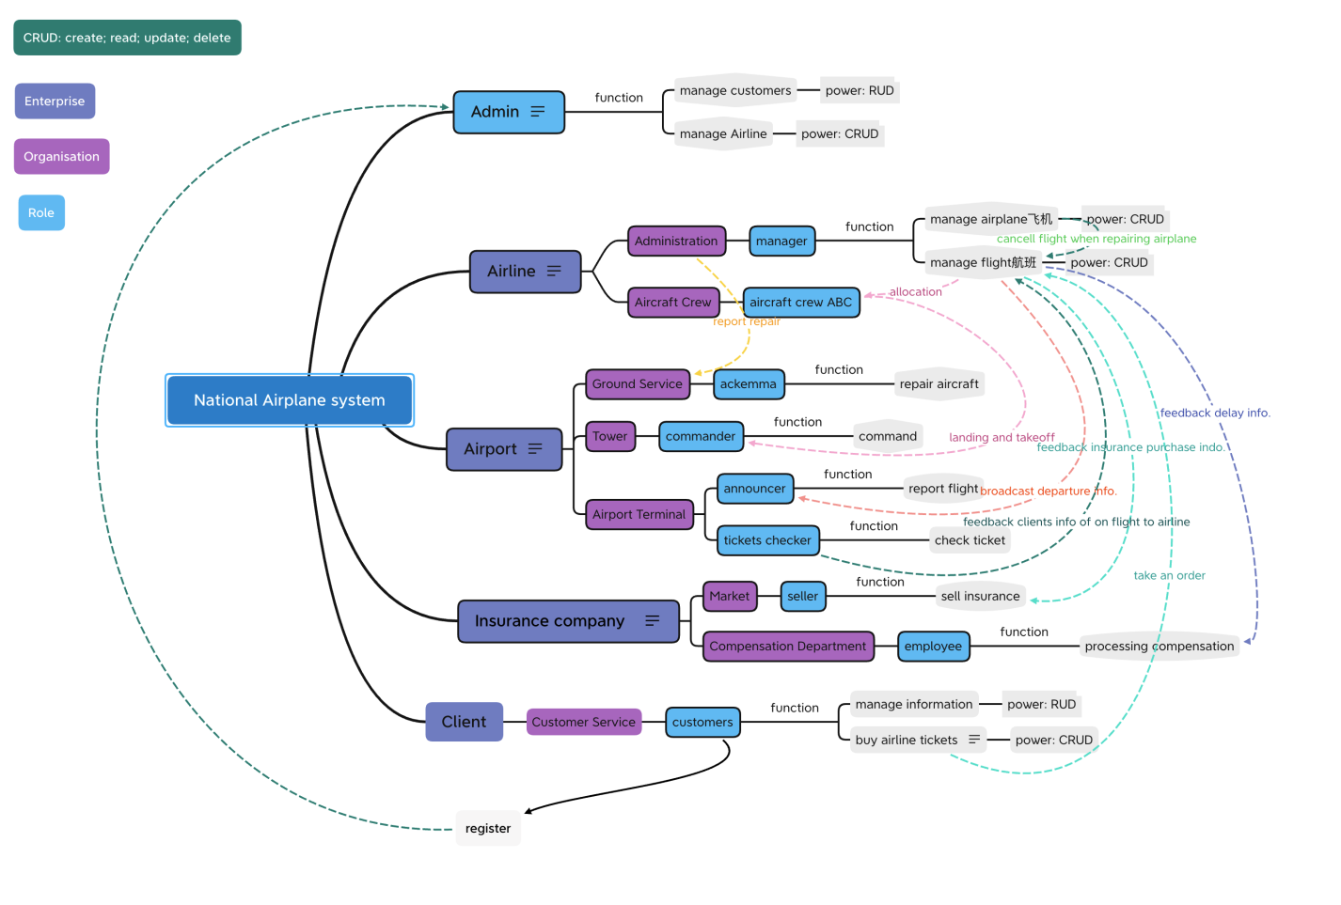

1. **Enterprise, Organization and Roles function:**

* Enterprise：
  + Airline: contain Administration organization and Aircraft Crew organization；
  + Airport contain Ground Servise organization, Tower organization and Airport Terminal organizations；
  + Insurance Company: contain Insurance Market organization and Compensation Department organization；
  + Client: contain Customer Servise organization ;
* Organization：
  + Airline Administration:
    - - deliver airplane repair info. to ground service.
  + Aircraft Crew: contain aircraft crew ABC role, which have one-to-one relationship with the flight；
    - + get flight info. from administration.
    - - deliver landing and takeoff info. to commander.
  + Ground Servise: contain ackemma role；
    - + get repair info. from Airline Administration.
  + Airport Tower: contain airport commander role；
    - + get landing and takeoff info. from Aircraft Crew.
    - - deliver later info. to Compensation Department.
  + Airport Terminal: contain announcer and tickets checker roles；
    - + get broadcast info. of flight from Airline Manager.
    - + record passenger info. from customer
    - - deliver passenger info. of one later flight to Compensation Department.
  + Insurance Market: contain insurance seller；
    - + get customers info. of purchase insurance from Airline Manager.
  + Insurance Compensation Department: compensation employee roles；
    - + get customer info. and flight late info. from tickets checker and Airline Manager.
  + Customer Service: contain customer servise；
    - - deliver register info. to Admin.
    - - get flight info. when customer but tickets.
* Role：
  + Admin: Manage Customers: RUD; Manage Airline: CRUD; Manage Insurance Company: CRUD.
  + Airline Manager: manage airplane; manage flight.
  + Aircraft Crew ABC: service with certain flight.
  + Ackemma: Repair Aircraft.
  + Commander: Command aircraft landing and takeoff；
  + Announcer: broadcast flight info.；
  + Tickets Checker: Check tickets；
  + Insurance Seller: sell insurance；
  + Insurance Employee: processing compensation；
  + Customer: manage info. ; buy tickets

1. **System Architecture**

1. **UML**
2. **Sequence Diagram**

Sequence diagram shows dynamic collaboration between multiple objects by describing the chronological order in which messages are sent between them. Users need to authenticate when logging in to the system.

After successful authentication, the user can see the home page. The user can apply for a request to update the information, which will be passed to the server to call the database information and returned to the home Page display. When a user changes information in a homepage, the information goes back to the database and overwrites the old data.

1. **Dashboard：**
2. **Summary:**

This system mainly simulates the flight ticketing system, and we have incorporated multiple organizational structures such as tower, terminal and insurance company. Compared with the traditional single ticketing system, it covers a wider range and updates data more timely. The mutual invocation of multiple roles strengthens several essential links of Java development that we have learned in class and enables us to have a more macroscopic and comprehensive understanding of development**.**

1. **Express Thanks：**

Time flies, half a semester passed in an instant. The fast-paced quizzes and assignments brought us international students a different experience. We would like to thank you again for TAs help and encouragement in this semester. Thanks for professor hard work in each class, which makes us full of confidence in our future study and life. I hope we can all become a small part of the computer field.